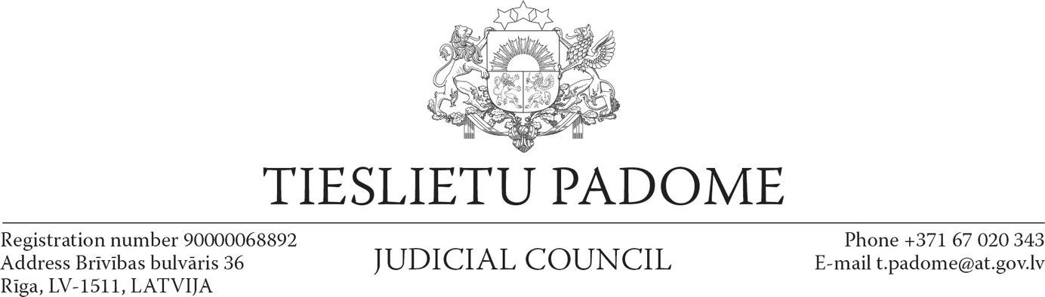

Riga

February 25, 2022

**Resolution on the value of democracy and the protection of sovereignty in Ukraine**

The Judicial Council of Latvia, as a collegial institution, has unanimously adopted the following resolution:

1. The Judicial Council of Latvia condemns the Russian military attack on Ukraine and the violation of Article 2 (4) of the Charter of the United Nations.
2. The Judicial Council of Latvia strongly supports Ukraine, its sovereignty and territorial integrity in accordance with international law.
3. This resolution is an expression of solidarity with Ukraine and its people in the fight for the protection of their national independence and democracy. At this tense and difficult time, the Judicial Council calls on Ukraine's colleagues – judges and independent legal professions – to be strong and steadfast, to protect Ukraine's constitution and the rule of law.

There is no place for war in Europe. The rule of law, freedom and dignity are the highest values ​​of democracy!

President of the Judicial Council A. Strupišs