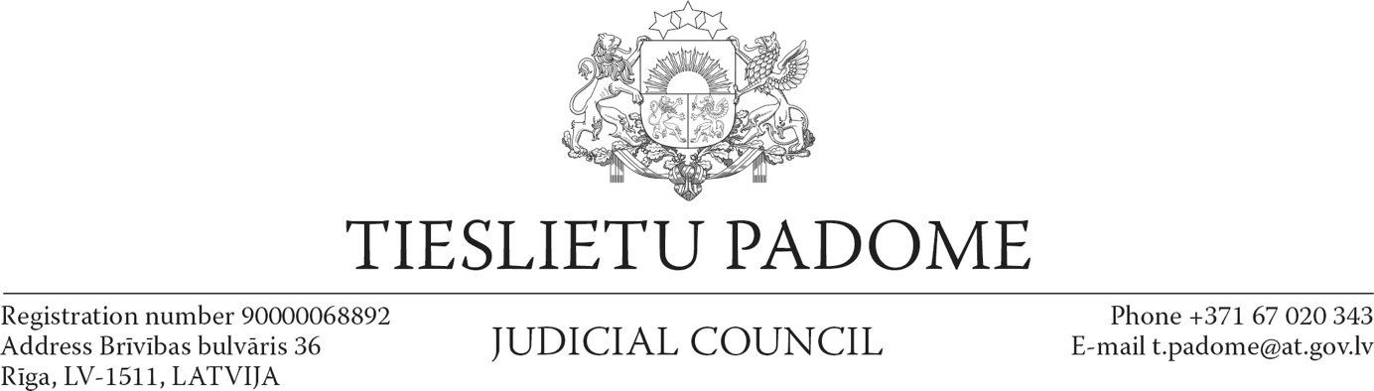

Riga

January 29, 2021

**Resolution on criticism of the judiciary and judges**

On January 22, 2021, the Minister of Justice Janis Bordāns gave a statement to the media on the course and result of the proceedings in the so-called "Magonis Case". In the article on the DELFI portal titled “Bordāns is indignant about the judgement in the Magonis and Osinovsky case; he questions the professionalism of the judge” it is stated by the Minister that "In a situation where there is a case that has a major impact on the public's confidence in the judiciary, this case, as a result of the judge's deliberate action, reaches a judge regarding whom the facts are known and the judges themselves have established that Jansons is not having the best reputation, nor he has the highest evaluation of professional work in the judiciary." The article also says that Bordāns would have preferred that a second evaluation of the judge’s performance had taken place before the judgement in the Magonis case was passed. It is also pointed out that in the Minister's view, the good news is that there is the appellate instance, while later Bordāns will decide whether the evaluation of the quality of judge Jansons’ work will have to be carried out by the Judicial Disciplinary Committee. [1] A similar attitude was expressed in the media by the Chair of the Legal Affairs Commission of the Parliament. [2] Part of the society has also supported this position on social networks.

In this situation, the Judicial Council considers it necessary to explain in the interests of the democratic system of the state and the independence of the judiciary that:

1. A full judgment is not yet available in the case in question. Consequently, it is not possible at present for anyone who has not taken part in the proceedings to express a reasoned opinion on the quality of this judgment. In addition, this judgment is not in force and can be appealed before a higher court.
2. A distinction must be made between criticism of a judgment, a court or a judge and insults. Criticism means expressing a civilized, concrete and reasoned opinion about shortcomings and mistakes. Dislike of the outcome of the judgment does not in itself give rise to criticism, especially if it is not followed by a reasoned justification.
3. The law prohibits influencing a judge in a case. This is one of the cornerstones of the rule of law.
4. The law does not provide grounds for suspending or dismissing a judge after receiving the first negative assessment of the Judicial Qualification Committee. In accordance with the procedure established by law, this judge must undergo an re-assessment under accelerated procedure, which finally determines the judge's tenure.
5. The Minister of Justice is one of the highest judicial officials in the country with a wide range of powers in the judiciary, including the right to initiate disciplinary proceedings against judges. Consequently, if such an official expresses an unfounded dislike of the result of the judgment, it may be perceived as unlawful influence of the judges who will review the case in higher instances.

           In view of the above, the Judicial Council calls all members of the public, including public officials:

1. To do not criticize the judgment before it is available, but to follow the principles of civilized discussion when expressing criticism.
2. To respect the principles of judicial activity and the independence of a judge specified in the Constitution and in laws.
3. In case the specific facts about corruption in the courts are known, to report them to the competent authorities, stating specific facts and evidence, but to refrain from unjustified insults of and rumours about court and judges, and from disseminating unverifiable allegations and false information.
4. Chairs of courts should organize effective court communication with the public, and judges are encouraged to explain abbreviated judgments by informing the public of the main arguments of the judgment.

The Judicial Council points out that the rule of law and democracy work well only in societies with a high level of civic awareness and legal culture, which includes, inter alia, education and knowledge about the state structure, including the structure and functioning of the judiciary. Statements that are not based on facts and evidence, and are based solely on emotions, do not demonstrate such a high level of awareness and culture, and only undermine the foundations of the state and society.

Chair of the Judicial Council Aigars Strupišs

1. https://www.delfi.lv/news/national/politics/bordans-sasutis-par-spriedumu-magona-un-osinovska-lieta-apsauba-tiesnesa-profesionalitati.d?id=52868075
2. https://www.delfi.lv/news/national/politics/jurass-pedejos-menesos-virmoja-runas-par-ietekmigu-viru-interesem-panakt-labveligu-spriedumu-magona-lieta.d?id=52863979